CSC/CPE 138 Lab 2 Valeriy Kutsar

1. My browser appears to be using HTTP 1.1 and the server is also running HTTP 1.1
2. The Accept-Language point says that my browser accepts US English.
3. My IPv4 address is 192.168.1.77. IP of the server is 128.119.245.12
4. 200 OK is returned.

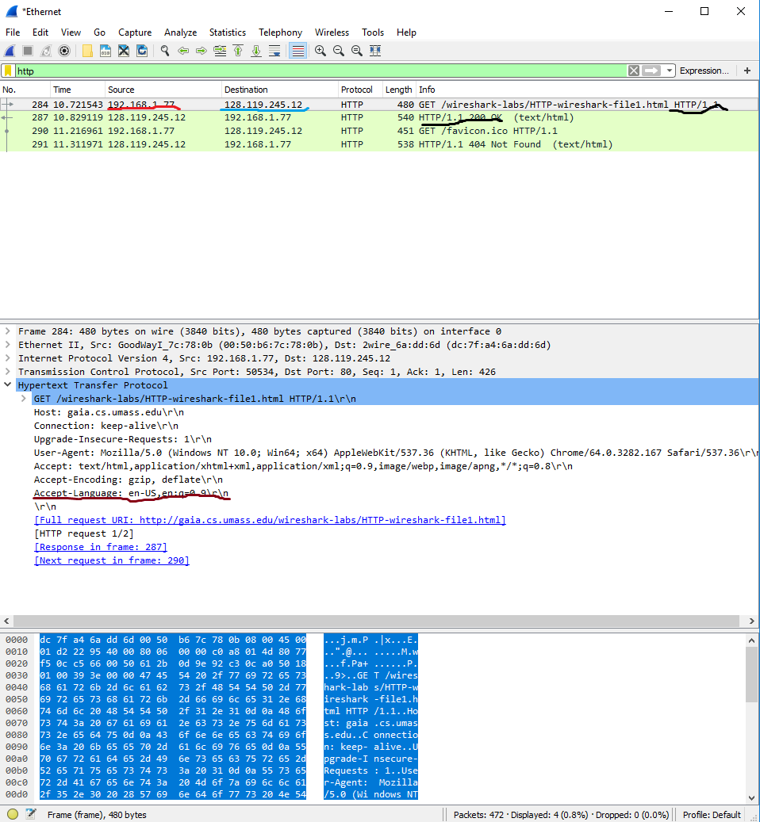

1. By doing a http.last_modified search in the filter, I get the response that says that the last time the file was edited was on February 25, 2018 at 6:59

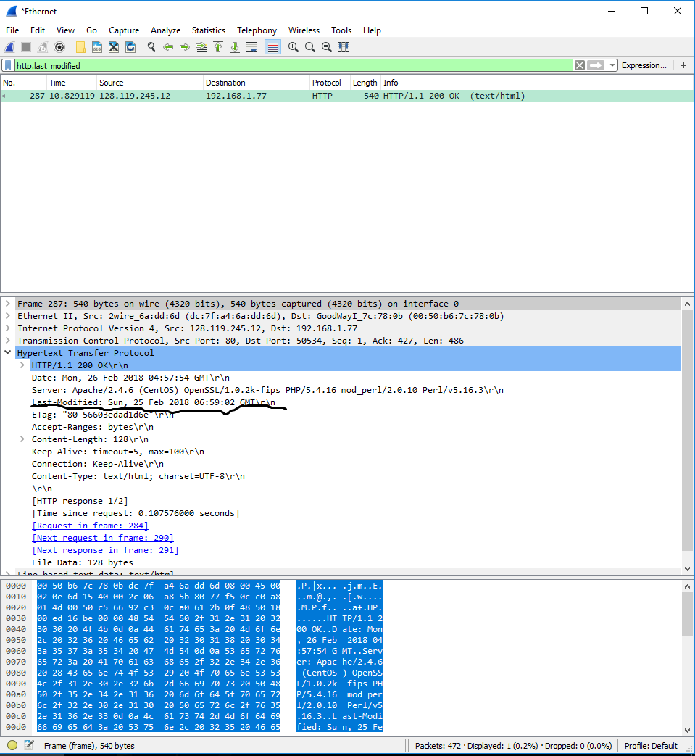

1. Content-length = 128 bits

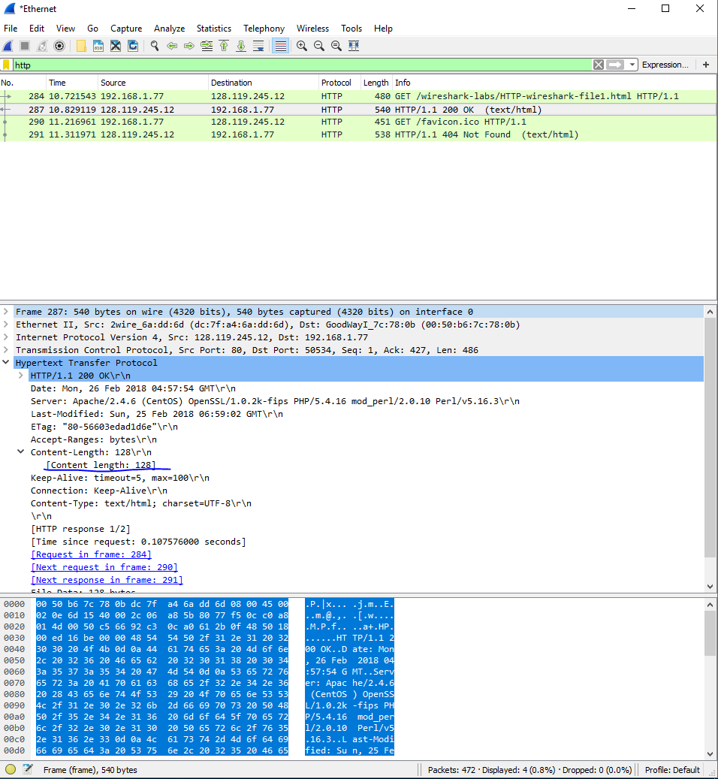

1. No, the raw data appears to match up with what is shown in the packet-listing window.
2. There appears to be no “if-modified-since” message

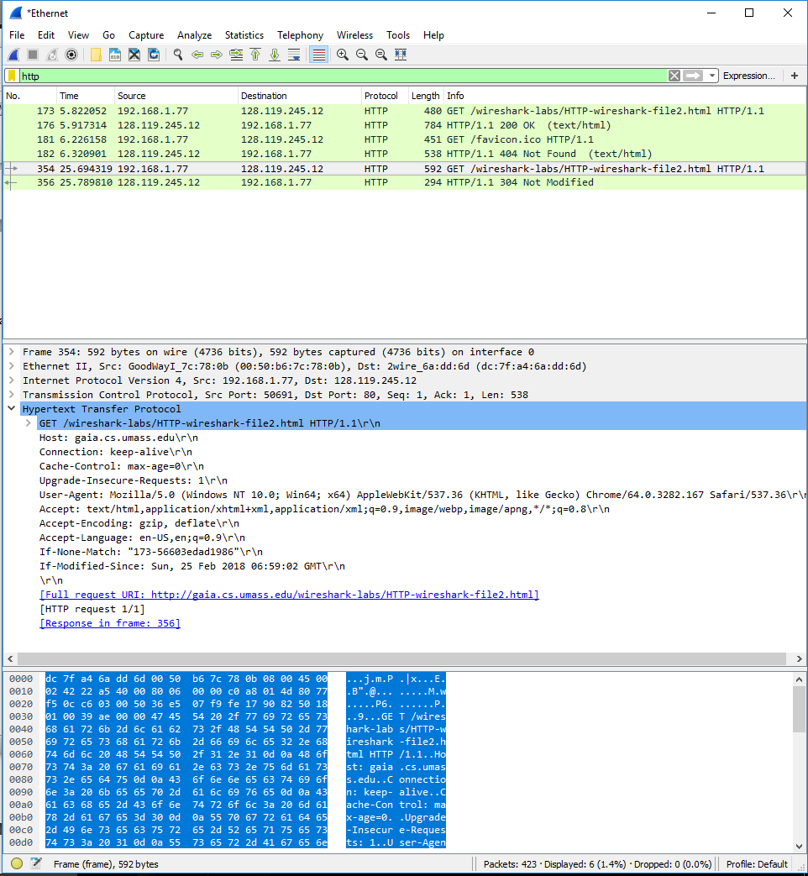

1. The line based text data tab shows the html text that was sent over.

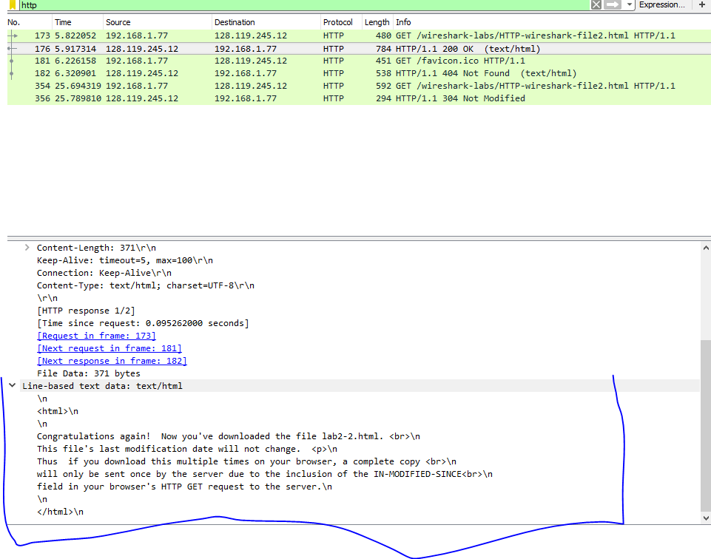

1. Yes. If-Modified-Since: Sun, 25 Feb 2018 06:59:02 GMT

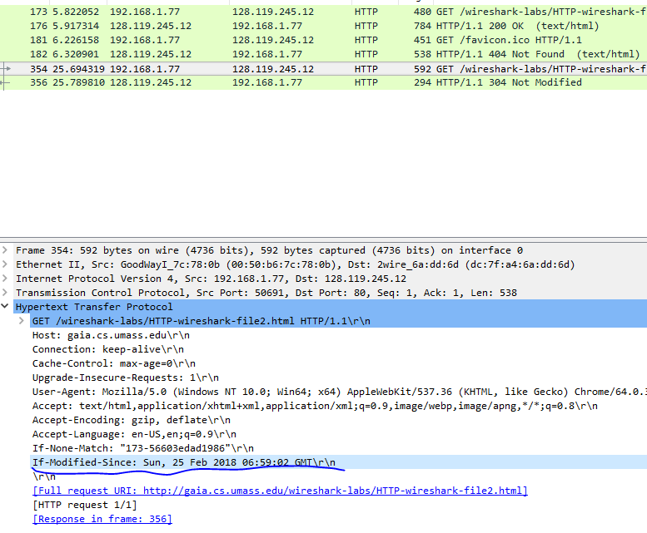

1. As seen in the previous screenshot, the message is a http 1.1 304 Not Modified message. This is much shorter than the full response from the previous response.
2. My browser sent one GET message. Packet Number 148.
3. Packet number 164 contains the status code and the phrase 200 OK.
4. Status code and phrase of the response is 200 OK.
5. 4 Segments were needed to carry the Bill of Rights to my browser.

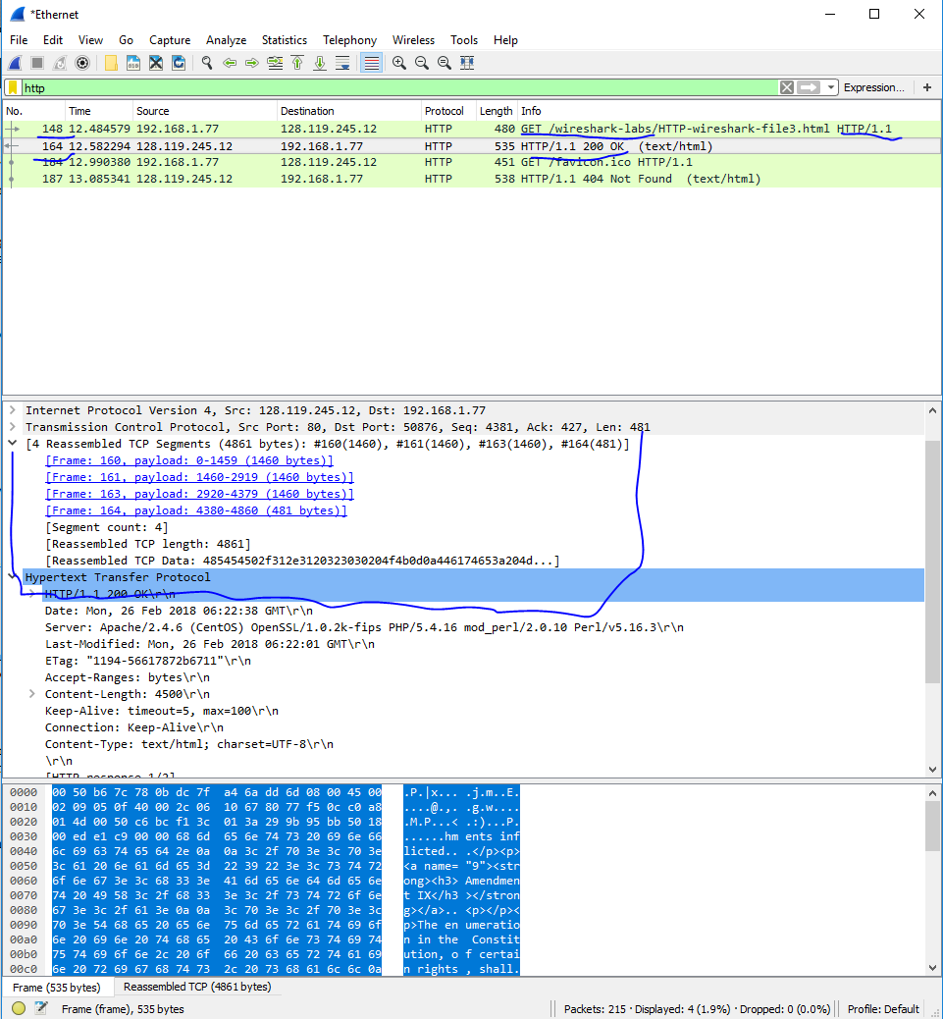

1. 4, not counting the favicon.io get message. The GET messages were sent to 128.119.245.12, and 128.119.240.90.
2. Based on the time stamps, it looks like the images were downloaded serially. Also the source port is incrementing from 50929, 50930 and 50932 which means the images were delivered serially over separate TCP connections.

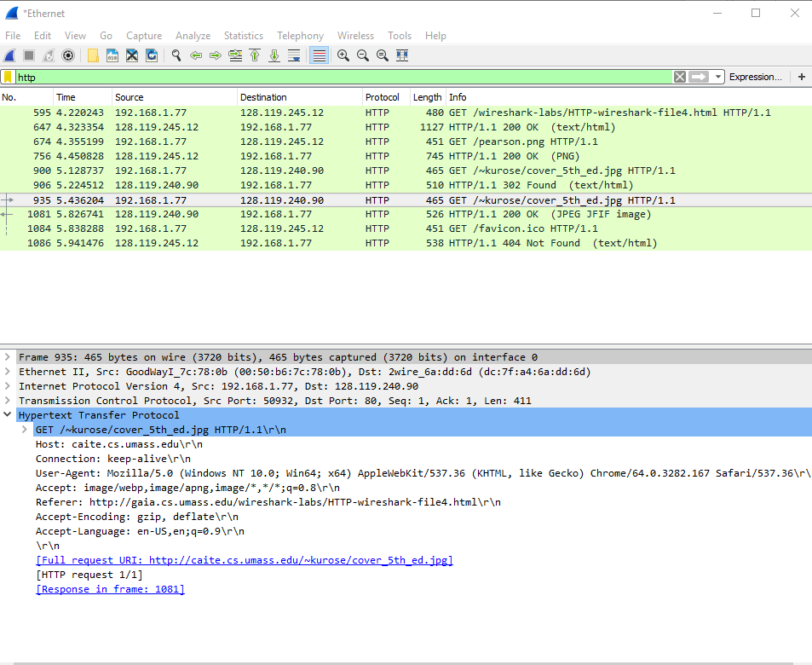

1. The initial response is HTTP/ 1.1 401 Unauthorized
2. An authorization field appears.

